­­

October Newsletter fountain.jenn@yahoo.com

Jennifer Fountain



Hey Everyone, It is that time of month again, NEWSLETTER time. Hope you all have had a good start thus far. We have some wonderful events coming up for the girls to par take in.

Events:

Service Unit Level:

**Skate Celebration (10/25)~Star Wars Theme (skating is always a fun event there will be a pumpkin raffle to help with scholarship funds.

**Camporee (11/11-1/13~never too old to participate)

**Babysitter/CPR (12/3)

Council Level Girl Events:

**[Gold Award Workshop](http://www.gs-top.org/en/events-repository/2016/gold_award_workshop_950601845.html)

Date: Tue Oct 18, 7:00 PM - 9:00 PM

Region: Fort Worth

Location: Southlake Service Center

**[ZAP (Zombie Apocalypse Preparedness) - Junior](http://www.gs-top.org/en/events-repository/2016/zap_zombie_apocalyps.html)

Date: Fri Oct 21, 7:00 PM - Sun Oct 23, 11:00 AM

Region: Fort Worth

Location: Stevens Ranch

*this one for those of you who are multi level groups*

**[Bronze and Silver Workshop](http://www.gs-top.org/en/events-repository/2016/bronze_and_silver_wo_1771630206.html)

Date: Sat Oct 29, 10:30 AM - 12:30 PM

Region: Fort Worth

Location: Corporate Office - Fort Worth

**[TCU Volleyball Clinic](http://www.gs-top.org/en/events-repository/2016/tcu_volleyball_clini.html)

Date: Sat Nov 05, 5:00 PM - 6:00 PM

Region: Fort Worth

Location: TCU Rickel University Recreation Center

**[Gold Award Workshop](http://www.gs-top.org/en/events-repository/2016/gold_award_workshop__325824763.html)

Date: Tue Nov 08, 7:00 PM - 9:00 PM

Region: Fort Worth

Location: Corporate Office - Fort Worth

**[Girl Scout Sleepover with the Dallas Cowboys](http://www.gs-top.org/en/events-repository/2016/girl_scout_sleepunde.html)

Date: Fri Nov 18, 7:00 PM - 8:24 PM

Region: Fort Worth

Location: AT&T Stadium (Home of the Dallas Cowboys)

**[Program Aide - Teen Mentoring Award](http://www.gs-top.org/en/events-repository/2016/program_aide_teen_me_1289516848.html)

Date: Sat Nov 19, 10:30 AM - 3:30 PM

Region: Fort Worth

Location: Southlake Service Center

(yours truly will be teaching this class!!)

**[VIT Volunteer in Training – Teen Mentoring Award](http://www.gs-top.org/en/events-repository/2016/vit_volunteer_in_tra_244250202.html)

Date: Sat Nov 19, 10:30 AM - 3:30 PM

Region: Fort Worth

Location: Southlake Service Center

**[National Cowgirl Museum and Hall of Fame Girl Scout Day](http://www.gs-top.org/en/events-repository/2016/national_cowgirl_mus.html)

Date: Tue Nov 22, 12:00 PM - 5:00 PM

Region: Fort Worth

Location: National Cowgirl Museum and Hall of Fame

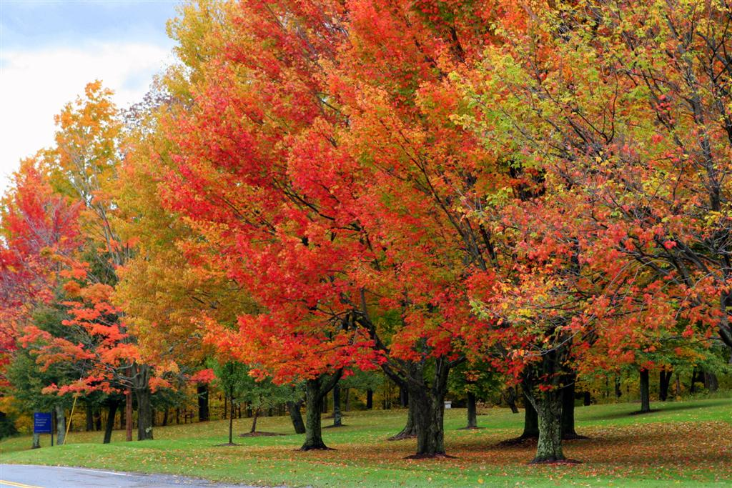

**!!!!New Website just for Fossil Creek Area!!!!!**

[**http://fossilcreekgirlscouts.weebly.com/**](http://fossilcreekgirlscouts.weebly.com/)

**copy and paste into url**

**all fliers can be found here for any events that our service unit host.**

**Please go to check it out very helpful**

**Councils Website:**

[**http://www.gs-top.org/en/events**](http://www.gs-top.org/en/events)

**Don’t forget that the websites has adult training and events too!**

**Council Adult Trainings:**

[**First Aid/CPR--Blended Learning**](http://www.gs-top.org/en/events-repository/2016/first_aid_cpr_blende_5252905.html)

**Date: Tue Oct 18, 6:00 PM - 8:00 PM**

**Region: Fort Worth**

**Location: Corporate Office**

[**First Aid/CPR--Blended Learning**](http://www.gs-top.org/en/events-repository/2016/first_aid_cpr_blende_5252905.html)

**Date: Tue Oct 18, 6:00 PM - 8:00 PM**

**Region: Fort Worth**

**Location: Corporate Office**

[**Outdoor 101**](http://www.gs-top.org/en/events-repository/2016/outdoor_101_1169514858.html)

**Date: Tue Nov 08, 6:00 PM - 9:00 PM**

**Region: Fort Worth**

**Location: Corporate Office - Fort Worth**

[**Outdoor 101**](http://www.gs-top.org/en/events-repository/2016/outdoor_101_361245150.html)

**Date: Tue Nov 15, 6:00 PM - 9:00 PM**

**Region: Fort Worth**

**Location: Corporate Office - Fort Worth**

**EXTRA FUN!!!**

**The escape room in Roanoke is open**

**Scavanger hunt in sun dance square**

**Ripleys Believe it or not**

**Ft worth/Dallas Zoo**

**Coyote Drive~in movie with ice skating (ft.worth)**

**Dallas aquarium**

**Haslet Hunted Hay Ride**